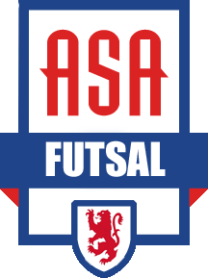

Frequently Asked Questions

What type of shoes should my child wear to futsal sessions? No cleats allowed for indoor futsal sessions. Shoes with flat soles only. To find out more about futsal shoes, please visit www.soccer.com and search “futsal shoes.”

When do we find out the exact time and location of each class? We anticipate that November 1st will be the latest we would have an exact schedule released. The goal is the week of October 24th if not sooner. We release the schedule as soon as it is finalized.

What determines the exact schedule like times and locations? There are MANY variables that go in to finalizing the schedule, particularly with the indoor schedule where indoor space is limited. Some of the variables include confirming available gym space with the city and number of registrations.

How will participants be grouped? Participants are grouped by age group, gender, travel or recreation player. Some age groups may be combined based on the number of participants. Generally, each class will have a maximum of 16 participants.

Will my child be in the same group as his/her fall team for the skills classes? For the skills classes in November and December it is not possible for us to ensure that every player will be grouped with their fall team or their friends. The players will be grouped by age group, gender, current program (recreation or travel), and in some cases appropriate skill level.

Will my child’s futsal skill class play together in the futsal league? No. However, you will have the option of team registration for this year’s team.

